High Voltage Battery State of Charge Mechanical Gauge – PHEV_BEV – CGEA1.3

Functional Description

The instrument cluster shall display in a mechanical gauge the High Voltage Battery State of Charge (HV Battery SOC) in a percentage value based on a CAN signal from the high voltage battery controller (BECM). The SOC gauge behavior between 0-100% shall be linear.

This STSS has limited applicability since most PHEV and BEV clusters will use a virtual gauge. In this update Low SOC telltale behavior is added in the STSS.

The IPC correlates the Operational Mode, BattTracSoc_Pc_Dsply and BattTracLoSoc_D_Dsply CAN signal to display the High Voltage Battery State of Charge.

Interfaces

Interface Context Diagram (I/O Block Diagram)
Figure 1 HV Battery SOC Gauge Context Diagram
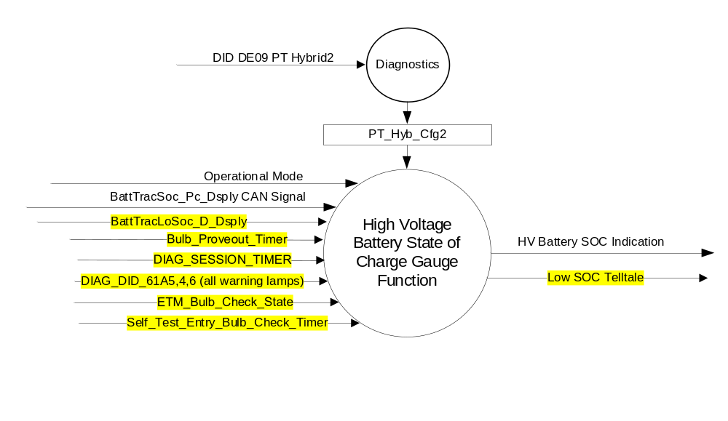

Inputs

- Internal
  - DIAG_SESSION_TIMER
  - Operational_Mode

- MUX messages on the CAN Network

- BattTracSoc_Pc_Dsply (CAN) Signal
Signal Name | Size (bits) | Detail | Units | Res. | Offset | State Encoded | Min | Max
BattTracSoc_Pc_Dsply | 8 |  | Percentage | 0.5 | 0 |  | 0 (0x0) | 126.5 (0xFD)
 |  | No Data Exists |  |  |  | 0xFE
 |  | Faulty |  |  |  | 0xFF

- BattTracLoSoc_D_Dsply Signal
Signal Name | Size  (bits) | Details | Units | Res. | Offset | State Encoded | Min. | Max.
BattTracLoSoc_D_Dsply | 2 |  | SED | 1 | 0 |  | 0x0 | 0x3
 |  | 0x0 |  |  |  | Null
 |  | 0x1 |  |  |  | LoDte
 |  | 0x2 |  |  |  | ZeroDteDepletedBattery
 |  | 0x3 |  |  |  | NotUsed_1

Outputs
- HV Battery SOC Gauge Indication
- Low SOC Telltale

Function/Performance

Operational Modes

Mode | Differentiating Vehicle Conditions
Sleep Mode | HV Battery SOC Gauge needle at “Rest Position”  Low SOC TT OFF
Limited Mode | HV Battery SOC Gauge needle at “Rest Position”  Low SOC TT OFF
Normal Mode | HV Battery SOC Gauge needle at “HV Battery SOC Indication”  Low SOC TT ON/OFF
Crank Mode | HV Battery SOC Gauge needle at “HV Battery SOC Indication”  Low SOC TT ON/OFF

Voltage Levels

Refer to Cluster Features table located in the Operational Modes and Voltage Range Strategies Section of this SPSS.

Human-Machine Interface

Visual

Indicator Graphics / Display Format
- The "100%" graduation mark shall be on the right side of the indicating field, except when using a vertically arranged field, in which case the "100%" graduation shall be on the top of the field.

- Application Graphics : SOC Mechanical Gauge
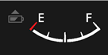

- SOC Indicator Graphics


Note : For exact design of Low SOC Indicator and SOC Mechanical Gauge use direction from Ford HMI for specific
program.

Indicator Color Coordinates

- Low SOC Telltale will be Amber in low SOC state.
- Reference section COLOR & ILLUMINATION REQUIREMENTS (GRAPHICS)

Indicator Characteristics

Description of Gauge | Scale Range | Scale Span | Operating Span
HV Battery SOC | “0%” to “100%” | 0 – 86 angular degrees | -4 to 89 angular degrees

- “Scale Span” refers to the span delimited by the center lines of the “0%” and “100%” markings.
- “Operating Span” refers to the High Voltage Battery State of Charge Gauge’s entire range of pointer movement over the graphics range.
- LED – Low SOC Indicator.

Audio

None

Switch Control Logic

Not Applicable

System Accuracy

- The HV Battery SOC Gauge Indication value shall be calculated within 100 msec of receiving a valid CAN Signal value.
- For a steady state input, the HV Battery SOC Gauge shall position its pointer on the input value with a tolerance of
+ / - 2 angular degrees.
- The HV Battery SOC Gauge Indication shall not lag the CAN Signal Input by a time greater than 300 msec.

Operation: Performance and Functional

Subsystem Algorithm Flowchart / State Diagram

- HV Battery SOC Gauge Indication based on BattTracSoc_Pc_Dsply (CAN) Signal
Operational Mode | BattTracSoc_Pc_Dsply | HV Battery SOC Gauge  Indication (angular degrees)
Normal or Crank | Never Received | 0
 | 0% (0x0) to 100% (0xC8) | BattTracSoc_Pc_Dsply * 0.5 / 86
 | 100.5% (0xC9) to 126.5% (0xFD) | 86
 | No Data Exists (0xFE) < 5 s | Hold last received value
 | No Data Exists (0xFE) >= 5 s | 0
 | Faulty (0xFF) < 5 s | Hold last received value
 | Faulty (0xFF) >= 5 s | 0
 | Missing < 5 s | Hold last received value
 | Missing >= 5 s | 0
All other cases |  | -4 (Rest)

- Low SOC Telltale

Operational  _Mode | PT_Hyb_Cfg2 | ETM_Bulb  _Check_  State | DIAG  _SESSION  _TIMER | Self_Test_  Entry_Bulb_ Check_Timer | DIAG_DID_  61A5,4,6  (all warning lamps) | Bulb_  Proveout_  Timer | BattTracLoSoc_D_Dsply | Low SOC Telltale
Normal  or Crank | PHEV  or  BEV | X | Inactive | X | X | Active | X | ON
Normal  or Crank | PHEV  or  BEV | X | Inactive | X | X | Inactive | 0x1, 0x2 | ON
Normal  or Crank | PHEV  or  BEV | ON (0X1) | Inactive | X | X | Inactive | X | ON
Normal  or Crank | PHEV  or  BEV | OFF (0x0) | X | X | X | Inactive | Missing as per 1.4.1 | ON
Normal | PHEV  or  BEV | X | Active | Inactive | Not Received | Active | X | ON
Normal | PHEV  or  BEV | X | Active | X | Not Received | Inactive | 0x1, 0x2 | ON
Normal | PHEV  or  BEV | ON (0X1) | Active | X | Not Received | Inactive | X | ON
Normal | PHEV  or  BEV | X | Active | X | ON (0x1) | Inactive | X | ON
Normal | PHEV  or  BEV | X | Active | Active | X | Inactive | X | ON
All Other Cases |  |  |  |  |  |  |  | OFF

Operation Description (supports algorithm flowchart /state diagram)

- The HV Battery SOC Gauge shall sample the BattTracSoc_Pc_Dsply Signal at the predefined message's periodic rate.
- The cluster shall use HV Battery SOC Gauge Indication to update the HV Battery SOC Gauge pointer position every 100 msec or less.
- The HV Battery SOC Gauge “Rest Position” shall be the position of the HV Battery SOC Gauge pointer when the centerline of the HV Battery SOC Gauge pointer is 4 degrees below the line intersecting the needle’s center of rotation and the centroid of the “0%” tick mark.
- The HV Battery SOC Gauge pointer shall traverse to the “Rest Position” within 1000 mS when in Limited Mode.
- Gauge pointer shall move to 0% grad at max rate when:
- BattTracSoc_Pc_Dsply Signal is No Data Exists (0xFE) for 5 or more seconds.
- BattTracSoc_Pc_Dsply Signal is Faulty (0xFF) for 5 or more seconds.
- BattTracSoc_Pc_Dsply Signal is Missing per section 1.4.1
- Gauge pointer shall move below the 0% grad to the Rest Position at max rate when:
- The IC operational mode transitions to Limited Mode.
- Microprocessor executes a hardware reset.
- Pointer overshoot and return to Battery SOC indicated by BattTracSoc_Pc_Dsply Signal shall not exceed one angular degree.
- Pointer movement shall appear smooth and continuous.
- The HV Battery SOC Gauge shall not exhibit needle waver exceeding 1/3 of an angular degree with a steady commanded input.
- No pointer stick shall be observed at any time.
- Target Gauge Pointer values are determined using the table in 1.3.5.1 with linear interpolation for values between entries in the table.

Function Safety Classification (EMC)

B

Memory Storage

Parameter Name | Description | Value at Battery Connect | Value at Module Wake-up
Operational_Mode | 4 state indicator for cluster operational mode | Limited | Limited or Normal or Crank
BattTracSoc_Pc_Dsply | CAN Signal | 0x0 | 0x0
BattTracLoSoc_D_Dsply | CAN Signal | 0x0 | 0x0
HV Battery SOC Gauge  Indication | Angular degree output of HV Battery SOC Gauge Indication | -4 (Rest Position) | -4 (Rest Position)
Low SOC Telltale | Low SOC Inidcator output | Off | Off
DIAG_DID_61A5,4,6 (all warning lamps) | Warning Lamp Status 2, byte 4, bit 6 (all warning lamps) | 0 (0x0) | 0 (0x0)
ETM_Bulb_Check_State | State indicator for warning bulb in ETM | Off (0x0) | Off (0x0)

Parameter Name | Description | Value at  Battery Connect | Value at  Module Wake-up
DIAG_SESSION_TIMER | Timer used to time-out a diagnostic session | Not Active | Not Active
Bulb_Proveout_Timer | Internal command directing proveout | Not Active | Not Active
Self_Test_Entry_Bulb_Check_Timer | Timer used in diagnostic session to do a self check of telltales | Not Active | Not Active

Prove Out

3.0 +/- 0.1 seconds as per bulb prove out section. Cluster controls proveout. No DTCs shall be logged while
Prove Out.

Reconfigurable Telltale

No

Error Handling

None.

Missing Message Strategy

The signals will be declared missing as per the Diagnostics section of this SPSS.

DTCs states and history will be determined as per the Diagnostics section of this SPSS.

Diagnostics

Self Test

None

Engineering Test Mode

Reference section “Dealer / Engineering Test Mode (ETM)”

Part II Performance

Reference Part II Diagnostic Specification

Supported Diagnostic DIDs (Service $22 and $2F)
Number | DID / CommonID Name | DID Type

Supported Diagnostic Trouble Codes (DTCs)

DTC | Description | When Logged
C11100 | Lost Communication with Battery Energy Control Module “A” | Missing Message for 5 seconds or more
C41286 | Invalid Data received from Battery Energy Control Module “A” | Invalid Data for 5 seconds or more

DID DExx
Block  Num | Block Description | Byte(s) | Bits | State: Description | "0" | "1" | Default | Comments/Information
PACKETED BLOCKS
$09 | Option Content (B&A) |  | 3 | PT Hybrid2(PT_Hyb_Cfg2)  0x0 = Non-Hybrid  0x1 = BEV  0x2 = FHEV  0x3 = PHEV  0x4 = MHEV |  |  | 0x0 | Default from cluster plant to be 0x0 if cluster can be used on a Non-Hybrid.
 | *Byte and bit location to be identified in Part II Specification for this cluster

Reference Specification
- Func. Criticality EC-0048
- Mod. PWR-up / Reset EC-0049
- Low-High Vol. Perform. EC-0058
- Jump Start EC-0062
- Voltmeter Accuracy IS-0004
- Instr. & Gauges (indic. Grad) IS-0015
- Gauge Durab. IS-0033
- Oper. Voltage Perf. IS-0052
- Oper. Voltage Func. IS-0053
- Sys. Audible Noise IS-0103
- Pointer Waver IS-0108
- Instr. Scale Dir. IS-0127
- Vibration - Gauge Perf. IS-0326
- Symbol Usage 01-0238 / 01-0239
- Symbol Leg. 01-0240
- Placement - Parts Loc. 03-0001
- Coolant Temp. Gauge - Normal Op 04-0034
- Glare/Reflections 16-0068
- Reflection 17-0018
- Robust Sound Quality 17-0032
- Harmony: Graphics / Font / Ill. 17-0040
- Placement Vis. ID 17-0051
- Ergo - Access. 17-0052
- Ergo - Operablility 17-0053
- Control & Display Loc. 17-0060
- Logical grouping Function and Usage 17-0062
- Assoc. of Controls with Disp. & elem. 17-0063
- Ill. Controls & Disp. 17-0074
- Id. Legibility 17-0081
- ID. Coding / Labeling 17-0083
- Logic of Op. 17-0120
- Op. Stereotypes 17-0121
- Interpretation 17-0122
- Feedback 17-0124

Revision History
SPSS Module Revision History

Revision Level | Name | Change Description | Date
1.0 | J. Gregoire | Initial Release. Feature owner: Tejas Sawant (tsawant).  Peer reviewed by Scott Watkins. | 4/18/2017
2.0 | H. Sharma | This request came to DICC from EPE team(Charbel Bourey- Supported by Wolfgang Krug) on 05/09/19 for V363 S2 cluster. Due to hardware limitation, this program has physical LED for SOC Telltale. All the changes are marked in Yellow color. DICC tracking number # 361  - Section 1.0 is updated to add BEV in the title  - Section 1.1, Functional Description is updated to add low SOC telltale and new CAN signal  - Secion 1.2.1 is updated to add new input signals BattTracLoSoc_D_Dsply, Bulb_Proveout_Timer, DIAG_DID_61A5,4,6, ETM_Bulb_Check_State, Self_Test_Entry_Bulb_Check_Timer and new output Low SOC Telltale.  - Section 1.2.2 is updated to add Table 1.1 to add new CAN signal  BattTracLoSoc_D_Dsply  - Section 1.2.3 is updated to list Low SOC Telltale as output.  - Section 1.3.1, Opertional Modes is updated to add SOC Telltale  - Section 1.3.3.2 Indicator Graphics / Display Format, is updated to SOC Telltale graphics.  - Section 1.3.3.2.1 Indicator Color Coordinates, is updated to add SOC Telltale color.  - Section 1.3.3.2.2, Indicator Characterstics is updated to add SOC Telltale color.  - Section 1.3.5.1 Subsystem Algorithm Flowchart / State Diagram, is updated to add Low SOC Telltale Colour  - Section 1.3.5.4 Memory Storage, is updated to add BattTracLoSoc_D_Dsply & SOC Telltale and other diagnostic parameters  - Section 1.3.5.5 Prove Out is output.  - Section 1.5.3 DID DExx, is updated to add PT_Hyb_Cfg2 | 08/20/2019

